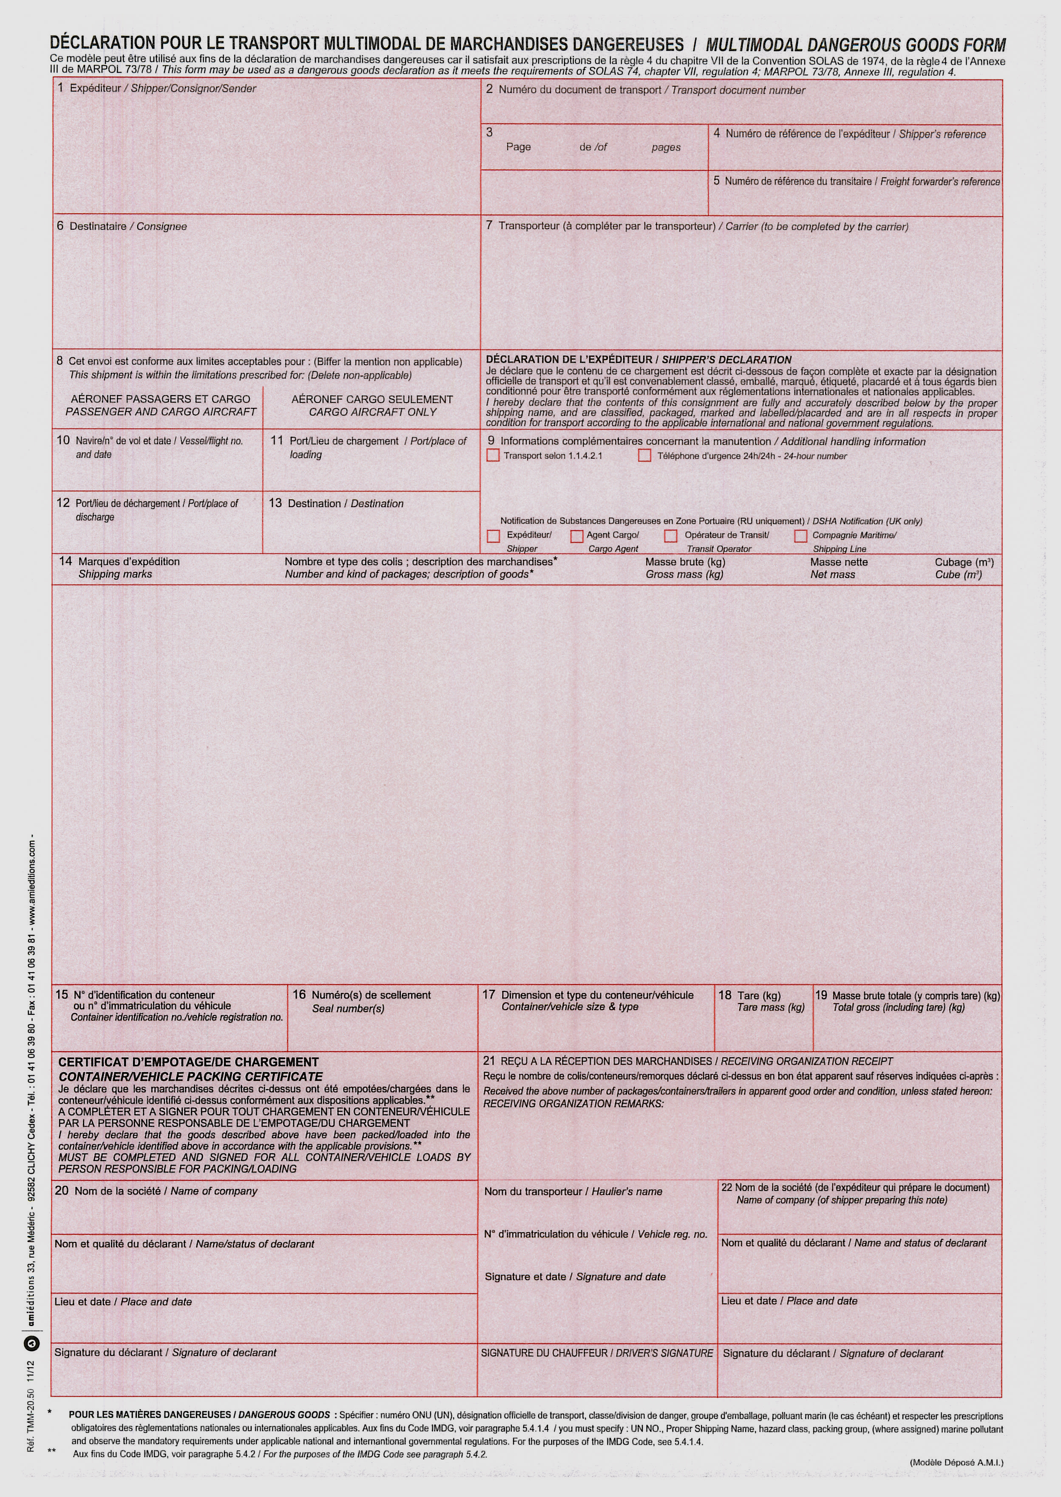
INTERNATIONAL LACQUERS S.A. PACKING LIST LCIL2109/19555
234, Z.A.E. WOLSER A
L-3225 BETTEMBOURG 1 1
LUXEMBOURG

KALYON Dagitim ve Pazarlama
Serifali Mah. Hattat SOK. N° 6
ÜMRENIYE – ISTANBUL
TURKEY

BETTEMBOURG PACKING GROUP II - NATIONAL
CHEMICAL EMERGENCY CENTRE PHONE NR: + 44 1865 407333

TURKEY

19 X 30 KG PLASTIC DRUMS 496,40 KGS 471,70 KGS

UN CODE 3H1/X1.9/250/19/B/AST-905304

27 X 25 KG METAL DRUMS 717,63 KGS 672,00 KGS

UN CODE 1A1/Y1.4/110/17/F/BVT229316FS

TOTAL : 31 DRUMS OF PAINT RELATED MATERIAL 1.214,03 Kgs 1.143,70 Kgs

Hazardous ingredients : light inflamable solvents: Ethyl acetate, Buthyl Acetat, nitrocellulose, resin
UN 1263, PAINT RELATED MATERIAL
CL 3, PG II, FLASHPOINT –4°C
SEGREGATION GROUP – NONE
(VAPOUR PRESSURE AT 50°C MORE THAN 110 KPA BUT NOT MORE THAN 175 KPA)

INTERNATIONAL LACQUERS SA INTERNATIONAL LACQUERS SA

SEBASTIEN KLEIN / SALES DEPT SEBASTIEN KLEIN / SALES DEPT

BETTEMBOURG –16/09/2021 BETTEMBOURG – 16/09/2021

